Title (bold, center, Times New Roman 14 pt)

Presenting Author¹, Co-Author^{2*}(initials and surnames, Times New Roman 11 pt)

¹ Complete postal address including, Zip code, City, Country
² Complete postal address including, Zip code, City, Country
*corresponding.author@emailaddress.eu

Please use this document as the template to your abstract. Please use MS-Word (.doc) format. The abstract has to be written in English and should be a conci
se description of the work presented without sections (Between 200 and 300 words maximum). Do not change page size or margins. Text (including Tables and Figures) must not be longer than one page. Please use Times New Roman font (11 pts), single spaced lines not indented and justified.
References should be listed and numbered at the end of the abstract, referred to by numbers in square brackets [1] and must have the following format:

References
[1] Authors (initials and surnames), Journal Title Abbreviation, volume, issue, year, initial-end pages.

Figures and Tables should be contained in the abstract, with the following format:

Insert Figure Here if Required (Use TIF/JPEG original files; please use uniform letter and sizing on your original artwork, considering a single column width [8.3 cm]; see next page for examples)
Figure caption should be in Times New Roman font (9 points). Please use this table as reference for final width of Figure

Table 1. Table Heading should be here (Times New Roman 9 points)
Heading 1 (Times New Roman 11 points) | Heading 2 / units in international system | Heading 2 / units in international system | Heading 2 / units in international system
Text | Data≠
≠ Include any special indication on the data presented as a footnote (Times New Roman 9 points)

NO FURTHER CORRECTIONS WILL BE PERFOMED TO THE ORIGINAL SUBMISSION AND THE ABSTRACT WILL BE PUBLISHED AS RECEIVED.

Save the file with the name and surname of presenting author (FamilynameGivenname.doc or FamilynameGivenname 1, 2, etc.doc in the case of multiple abstract submissions).

All submissions will be made by e-mail to: energysd@ifuap.buap.mx. Receipt of your abstract will be confirmed by e-mail.

The following are examples of formatted Figures (with no table borders). Axis Titles and in-Figure characters are formatted in Times New Roman 36 points, bold, while corresponding scales are Times New Roman 24 points, bold characters. Each data segment in the scatter plot is of 15 points. All this formatting occurred in the original files and here are presented for the 8.3 cm width.

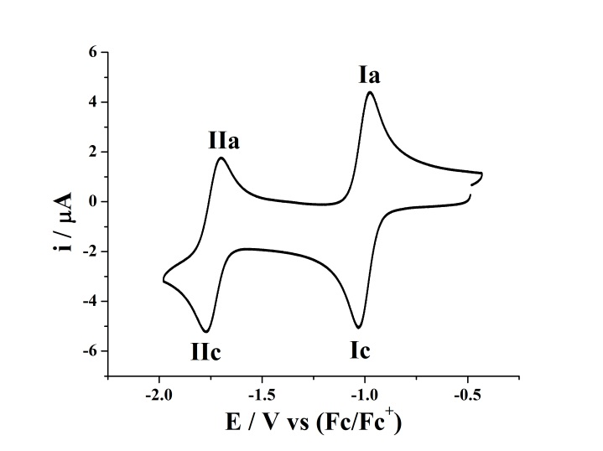
Figure 1. Cyclic voltammogram of xyz.

